**Department of Computer Science**

**CS – 2nd Year – A**

**Course No : CS-458**

**Team Orbit**

**Team Members:**

**Husain Ahmad Khan B23110006045**

**Muhammad Hamza Abbas B23110006096**

**Muhammad Hasan Khan B23110006099**

**Muhammad Mujtaba B23110006107**

**Rayyan Ibrahim B23110006137**

**Backend Design**

Backend Classes/Entities

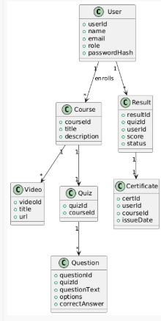

Backend Services

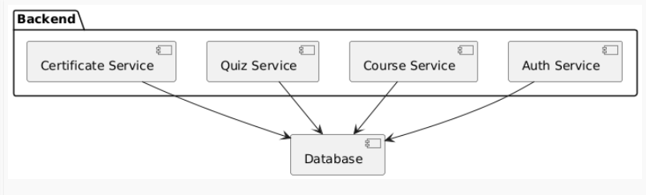

Video Lectures Module

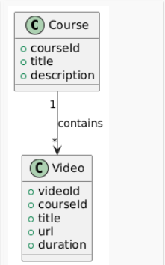

Video Streaming

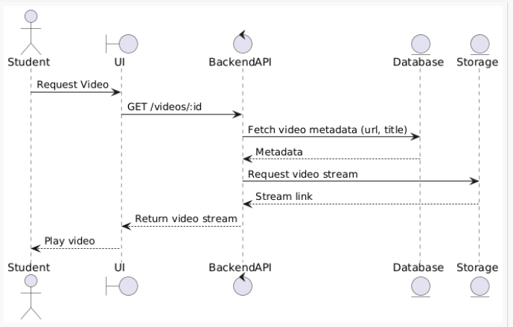

Auto-Grading Module

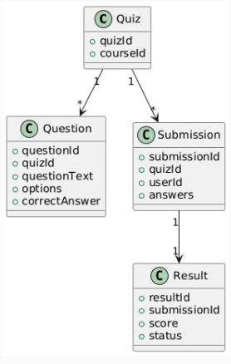

Auto-Grading

